EPA/600/R-20/XXX
Updated 07/2022

Water-On-Wheels (WOW) Mobile Emergency Water Treatment System Cart

User Manual
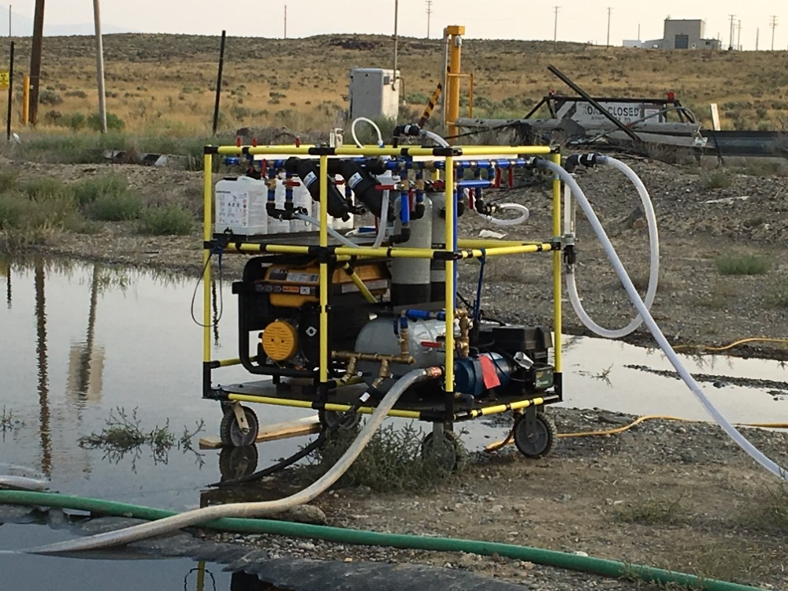

Kurtis T. Daniels, Ashley Hall, and Rebecca Dever
WaterStep
Louisville, KY 40208

James A. Goodrich and John S. Hall
U.S. Environmental Protection Agency
Cincinnati, OH 45268
Table of Contents
Disclaimer iv
Abbreviations v
Acknowledgements vi
Rights Reserved vii
Warning viii
Liability Statement ix
Introduction 1
Parts Description 10
Generator 10
80W Solar Panel 10
Battery with Box and Charger 10
Jet Pump and Pressure Tank 10
1250 Gallon Bladder Tanks 10
Filter Canisters 11
M-100 ChlorineGenerator 11
5 Liter Jerry Cans and Bleach Generator 11
Disc Pre-filters 11
Outlet Box A 12
Outlet Box B 12
3/4" Female Camlock to MHT Adapter 12
WOW Cart Manifold 12
Single Hole Manifold 12
Hoses 13
Additional Treatment 13
Field Set-up and Installation 13
Water Treatment 15
Connecting the Water Source 15
Pressurized water source from a hose: 15
Unpressurized water source: 15
Filling Bladder Tanks with Treated Water 18
Recirculation of Treated Water 18
Polishing Set-up Procedure 18
Additional Disinfection Set-up 19
Treated Water Distribution 20
Direct Distribution to Individuals 20
Pressurized Distribution Set-up Procedure 20
Cleaning, Storing, and Transportation 21
Cleaning 21
Storing 21
Generator 21
Transportation 21
Maintenance 22
Troubleshooting 23
Contact Information 24
Glossary 25
Appendix A. Alternative Water Treatment Flow Paths 28
Moderately Contaminated Water 28
Quick Disinfection 28
Appendix B. Manuals 29
Appendix C. Filter Media Types and Uses 30
Appendix D. Supplemental User's Guide for Standard Use & Configuration………………34

List of Figures
Figure 1. WOW Cart Field Installation Set-up 13
Figure 2. Electrical Configurations 14
Figure 3. Water Supply Connections 15
Figure 4. Complete Treated Water Flow Path 16
Figure 5. Recirculated and Treated Water for Distribution 19

List of Tables
Table 1. Parts List 2
Table 2. Fully Operational Flow Path 17

Disclaimer
The U.S. Environmental Protection Agency (EPA) through its Office of Research and Development funded and managed the research described herein under Cooperative Research and Development Agreement # 865-15 with WaterStep and contract EP-C-12-014 with Aptim Federal Services, LLC (APTIM). It has been subjected to the Agency’s review and has been approved for publication. Note that approval does not signify that the contents necessarily reflect the views of the Agency. Any mention of trade names, products, or services does not imply an endorsement by the U.S. Government or EPA. The EPA does not endorse any commercial products, services, or enterprises.

The contractor role did not include establishing Agency policy.

Abbreviations
APTIM Aptim Federal Services, LLC
EPA Environmental Protection Agency
FHT female hose thread
Ft³ cubic foot
Ft² square foot
GAC granular activated carbon
GFCI ground-fault circuit interrupter
gpm gallon per minute
INL Idaho National Laboratory
lb pound
MHT male hose thread (National Hose – NH)
ppm parts per million
PSI pounds per square inch
USB universal serial bus
UV ultraviolet
V volt
W watt

Acknowledgements

Contributions from the following individuals to the field work described in this report are acknowledged: Sue Witt, Gary Lubbers, Dave Elstun, and John Brannon of Aptim Federal Services, LLC.(APTIM); Mark Hogg, Bill Parker, Dr. Joe Jacobi, Larry Friebert, Dr. Cindy Figueroa, Lynn Smith, and Dustin Alton Strupp of EDGE Technologies; and Stephen Reese of the Idaho National Laboratory (INL).

Rights Reserved

A patent application has been filed at the U.S. Patent and Trademark Office for the technology described in this manual, including the cart, its components, and method of use, by the U.S. Environmental Protection Agency. A license from the Agency or WaterStep is required for use of the technology by non-Federal third parties.

Warning
Read this manual and all manuals of the individual components before assembling and operation of the Water-On-Wheels Mobile Emergency Water Treatment System Cart (WOW Cart).

Improper assembly, adjustment, alteration, service or maintenance can cause injury or property damage. If information in this manual is not followed as described, it may result causing property damage, personal injury or loss of life.

When operating the WOW Cart, always wear hearing and eye protection.

The WOW Cart weighs 750 pounds and should not be moved or lifted alone.

Remove generator from the WOW Cart and place at least 15 feet away prior to turning on.
Keep fire extinguisher within reach.

To avoid electrical shock from generator, outlet boxes, battery, and power supply, keep the WOW Cart and all extension cords out of standing water

Ensure electrical components are shielded from moisture.

Operate the WOW Cart in a well-ventilated area.

If using the WOW Cart near a body of water, take precautions to prevent drowning.

Once finished using the WOW Cart, dispose of chlorine generator byproducts appropriately per local discharge criteria or guidance. Discard byproducts after 14 days of storage, if kept for use.

Wear appropriate eye protection and gloves when handling bleach and chlorine. Keep bleach and chlorine generator byproducts (if using) in marked non-drink containers clearly labeled “POISON DO NOT DRINK.” These chemicals are corrosive. Store them out of direct sunlight in a cool, dry place. Keep out of reach of children and animals. Do not breathe in gas from any ports or tubes. Do not ingest. Call poison control if swallowed. If any chemicals get in eyes or on skin, flush thoroughly with safe water.

Both the generator and solar panels are valuable pieces of equipment, especially after a disaster. They are easily transported and not directly connected to the WOW cart. Because of this, they are targets for theft. Keep them in sight and attended to at all times.

For precautions about specific WOW Cart components, see their individual user manuals. (Appendix B)

For chemical storage and safety information, review the specific Safety Data Sheets for any chemicals acquired.

Liability Statement

The EPA and U.S. Government shall be held harmless and will not be liable for any demands, damages, expenses, and/or losses resulting from the use or misuse of the WOW Cart. As EPA has no control over the use, setup, modification or misuse of this equipment, no liability shall be assumed nor accepted for any resulting damage or injury. By the act of using the WOW Cart, the user accepts all resulting liability.

The training supplied with the purchase of the WOW Cart is imperative to effectively understand and use of the WOW Cart safely.

Introduction
The WOW Cart is the culmination of a collaborative venture between WaterStep and the USEPA Office of Research and Development via a Cooperative Research and Development Agreement (CRADA). A CRADA enables the U.S. Government to work directly with private companies pooling their technical expertise with each partner also providing in-kind resources to develop new intellectual property and technology that can be used for the protection of public health and the environment following a natural disaster. The WOW Cart is designed to produce up to 10 GPM of treated water, provide removal of a broad suite of water contaminants, be easily transported and operated, be capable of being powered by multiple electrical and solar sources, and inexpensive to own and operate.

Because of its low cost and simple operation, the WOW Cart can be utilized by non-profit humanitarian relief organizations, First Responders, and owner/operators of critical institutions such as hospitals, prisons, and businesses that must remain open during and following a natural or man-made disaster. A full report on the development, testing, and deployment of the WOW Cart is available at:

https://cfpub.epa.gov/si/si_public_record_report.cfm?Lab=CESER&dirEntryId=348196

Table 1. Parts List

Component | Quantity | Image
Generator | 1 | 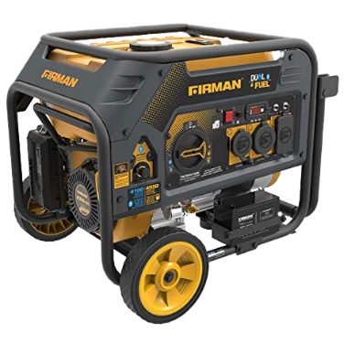
80W Solar Panel | 1 | 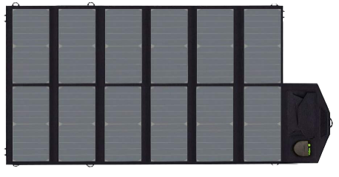
Group 24 12V Battery | 1 | 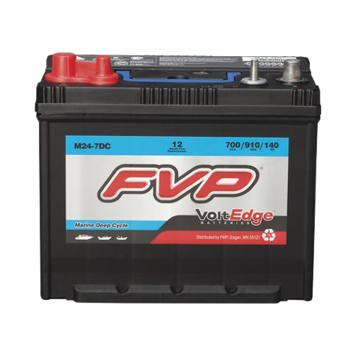
Battery Box | 1 | 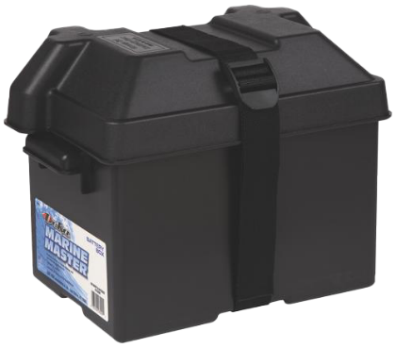
Battery Charger Kit | 1 | 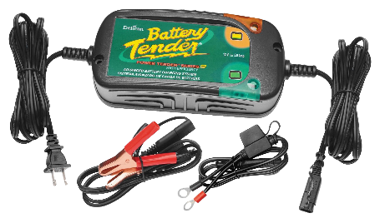
Jet Pump with Pressure Switch | 1 | 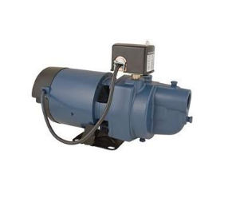
Pressure Tank | 1 | 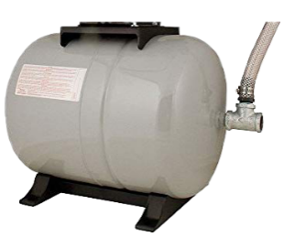
1250 Gallon Bladder Tank  (color may vary) | 2 | 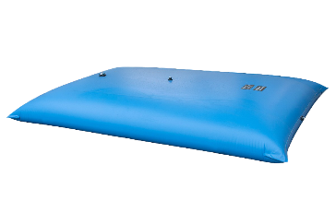
Carbon Filter Canister  (color & shape of filter body may vary) | 2 | 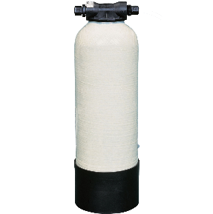
Replacement Filter Media  (carbon and sand) | 2 | 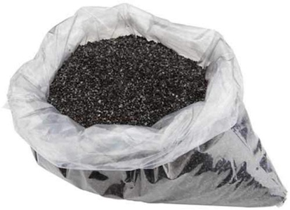
M100 Chlorine Generator Kit and Hose | 1 | 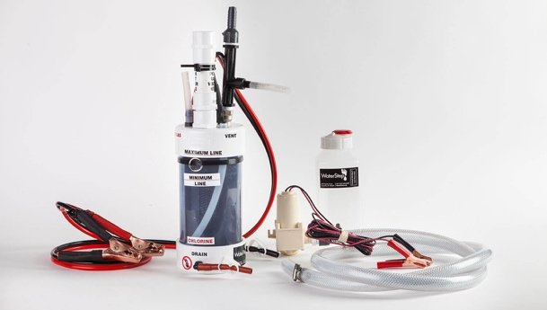
5 Liter Jerry Can  (color and shape may vary) | 5 | 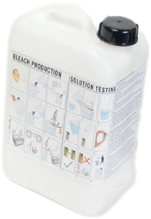
Bleach Generator Kit | 2 | 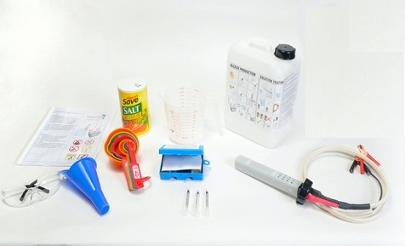
Power Supply | 3 | 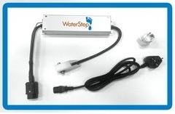
UV Water Unit | 1 | 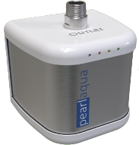
100-Micron Screen Filter w/Housing  (shape of filter body may vary) | 1 | 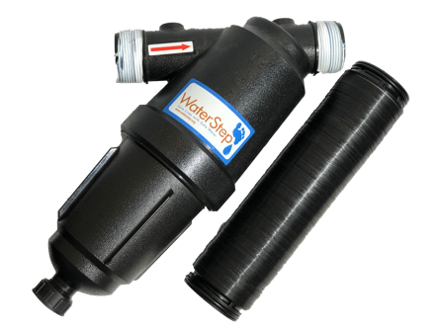
55-Micron Disc Filter w/Housing  (shape of filter body may vary) | 1 | 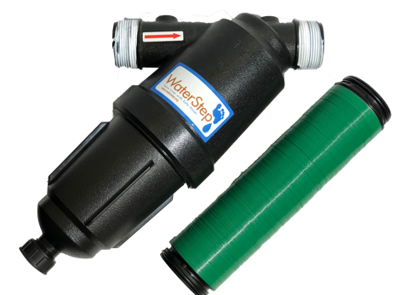
Outlet Box A | 1 | 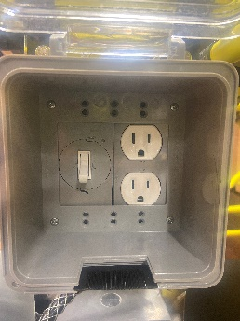
Outlet Box B | 1 | 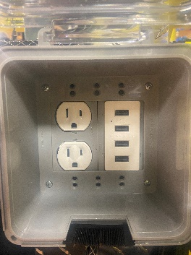
3/4” Male to Male Camlock Adapter | 1
3/4" Female Camlock  to Male Hose Thread (MHT) Adapter | 1 | 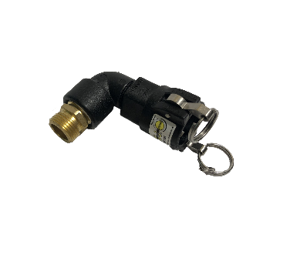
WOW Cart Inlet Manifold | 1 | 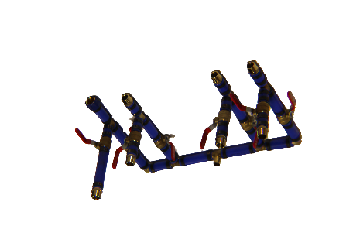
WOW Cart Outlet Manifold | 1
3/4" Female Camlock Cap | 21 | 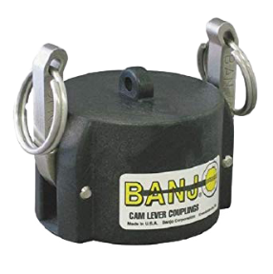
1" Female Camlock to MHT Adapter | 1 | 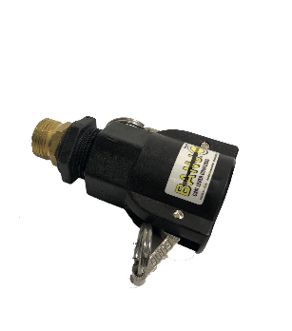
Female Hose Thread (FHT) Hose Cap  (also called National Hose – NH) | 5 | 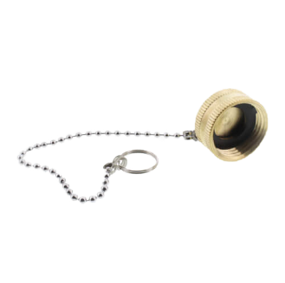
Bypass Hoses  36-inch, 5/8” ID | 8 | 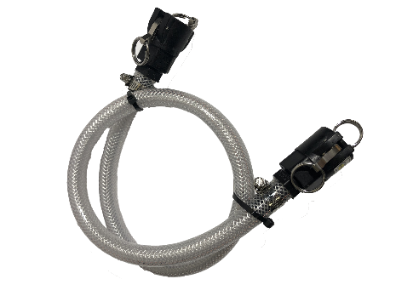
20’ x 5/8” Pressure Hose | 1 | 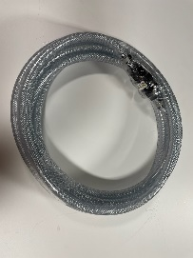
Bungee Cord | 1 | 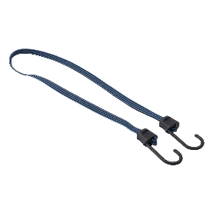
Single Hole Manifold | 2 | NEED NEW PICTURE!!
Drinking Water Safe Hose  (25’ each) | 2 | 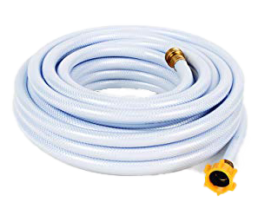
1" Suction Hose  (1” x 10’ each) | 2 | 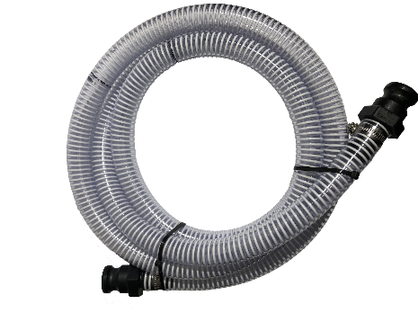
Foot Valve Assembly | 1 | 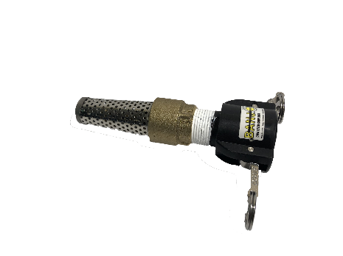
1" Female  to 3/4" Male Camlock Adapter | 1 | 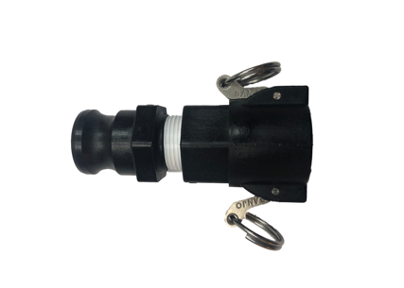
Female Hose Thread (FHT) to FHT Swivel Coupler | 2 | 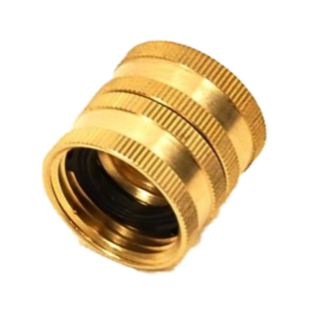
Check Valve | 1 | 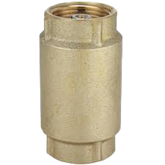

Parts Description

Generator/Dual Fuel
The generator is used as the primary power source and can use either propane or gasoline. When setting the generator up for use, place it at least 15 feet away from the WOW cart (the length of the appliance cables) and oriented so that the exhaust is away from other objects (the exhaust is hot and will burn objects near it.) There are two appliance cables connected to the cart AC electrical system. These cables should be connected to the generator to supply electrical power to the outlets. The jet pump, the battery charger and the AC / DC Power Supplies can now be energized by the generator through the WOW cart’s electrical system. See Outlet Box A and Outlet Box B on page 4.

80W Solar Panel
The solar panel should be hooked up to the battery whenever possible so that the battery remains charged. The solar panel is equipped with a voltage regulator that will allow the solar panel to be connected to the battery even when the battery is being used by a piece of equipment, such as the M-100 Chlorine Generator or the BleachMaker. The panel can be laid on top of the WOW cart or one of the bladder tanks. Because it is valuable and not attached to the WOW cart, solar panels are often stolen and should not be left unattended.

Battery with Box and Charger
The battery acts as a backup power source for the M-100 ChlorineGenerator and BleachMaker. It is stored in a marine battery box to protect it from the elements. The battery box has a battery charger attached to it that can be hooked up to the generator or one of the WOW cart’s electrical outlets if solar power is not available. It is recommended that the battery be hooked up to a power source at all times to keep the battery charged. There are indicator lights on the battery charger that will indicate the energy in the battery.

Jet Pump and Pressure Tank
The jet pump can be used to draw water from the untreated source through the primary treatment scheme and into the bladder tanks. It can also be used to push water from the bladder tanks to the distribution system and through polishing treatment, if desired. The jet pump has a pressure switch attached which will automatically turn the pump on and off as needed, so manual control is not necessary during distribution.

1250 Gallon Bladder Tanks
The bladder tanks are used to store treated water during chlorine contact time and until it is distributed. The tanks can be used on a batch system with one ready to use while the other is undergoing contact time.

Filter Canisters
The filter canisters can be filled with the desired media type to treat specific pollutants. The included media is granular activated carbon (GAC) which can be used to polish the water by removing residual chlorine, taste, and odor, as well as various organic chemicals. Filter canisters are directional, (as seen on the arrows at the connection points). So, ensure they are incorporated into the flow path in the correct orientation before using. The canisters can be removed and used externally for ease of distribution. To attach the canister externally, you will need to use the 1" Female to 3/4" Male Camlock Adapters to couple a bypass hose to the suction hose for distribution. It is suggested to replace the carbon every three years with “normal household use.” Two replacement media are included with the WOW cart. The 3/4” Male to Male Camlock Adapter can be used to connect the two filter media canisters together. While it is recommended to use one canister at a time so that the other can be used as a backup if filter media needs to be switched, the option does exist to run them in tandem. Additional information on other media and their applications can be found in Appendix C.

M-100 ChlorineGenerator
The M100 ChlorineGenerator produces chlorine gas that is drawn into the water stream via suction to chlorinate and treat the water. During operation, chlorine levels in the treated water need to be monitored so chlorine concentrations remain at the desired level per local requirements. Once the desired volume of water has been chlorinated to the desired level, a contact time of one hour is recommended. After one hour, test the free chlorine again. If the free chlorine level is at the required level, then the water can be distributed for its intended use.

5 Liter Jerry Cans and Bleach Generator
The bleach generator (BleachMaker) can produce about one gallon of bleach in 1 hour, 10 minutes (70 minutes) with only 1 ½ cups of table salt and electricity provided by the battery. The WOW cart has a total capacity to produce bleach in excess of 5,000 PPM with a capacity to store up to five gallons (~19 liters) of bleach. The bleach is equivalent to about a 1% solution of store-bought bleach and can be used in general and medical sanitation applications, to sanitize the disc filters, and to shock pre-existing tanks that have been contaminated. Secure the jerry cans during transport with the included bungee cord.

Screen/Disc Pre-filters
Both screen and disc filters can be used to filter out larger sediment particles before any other treatment. The 100-micron (screen) filter should be placed before the 55-micron (disc) filter, as they come on the WOW cart. The filters should be cleaned once there is a noticeable pressure drop in the treatment process. To clean the filters, release pressure from the system, remove the screen/disc element from the housing, and unscrew it so the screen/discs are loose. Spray the edges of the loose discs with clean water and sanitize with bleach. After sanitizing, screw the element back together until the screen/discs are hand tight. Flush the housing with clean water before replacing the screen/disc element back into the housing. Tighten the housing until hand tight and back off 1/8 a turn. Turn the valves after the screen/disc filters to the closed position and turn the supply side valves on to re-pressurize the filters before using.

Outlet Box A
The top outlet box (Outlet Box A) contains two wall ports and a switch. The jet pump should always be plugged into Outlet Box A, NOT INTO THE GENERATOR, so that the switch can act as a manual control. The electrical cord from Outlet Box A can be plugged directly into the generator.

Outlet Box B
The lower outlet box (Outlet Box B) contains two wall ports and 4 universal serial bus (USB) outlets. This outlet box can be used as a charging station for personal electronics, such as phones and computers. It is also a good place to plug in utility lights and the battery charger, if needed. The electrical cord from Outlet Box B can be plugged directly into the generator.

3/4" Female Camlock to MHT Adapter
This adapter is used at the input side of the manifold to attach a pressurized water source to the WOW cart. In this case, the jet pump is not required to draw water from a source and into the tanks. The Camlocks can operate under normal operating pressure (30-150 PSI in the US) from municipal source but if high pressures are present, install a PRV on the brass manifold.

WOW Cart Manifold
The WOW cart’s blue manifold is used to control the water flow path through the treatment process. There are twelve cam lever caps included which can be attached to the open ends of the bypass hose connections. It is recommended that the caps are placed on open ends to reduce the risk of contaminants entering the manifold. The 1" Female Camlock to MHT Adapter can be used at the outlet point of the manifold so that it can be hooked up to a hose and distributed to holding tanks or for use. The hose caps can be used to cover unused hose bibbs to prevent contamination from entering the WOW cart. Bypass hoses can be used to route water around undesired treatment steps through the WOW cart.

Single Hole Manifold
The single Hole Manifold is a manifold system that allows untreated water to be drawn from the tank(s) while at the same time, returning treated water back into the tank(s) through a single tank opening. There are two Single Hole Manifolds included with the WOW cart. Each Single Hole Manifold consists of one water inlet and three port openings. One of the ports is fitted with a 1” Camlock Male Adapter, another with a full port ball valve for testing chlorine levels, and the final with a hose adapter for distribution of the treated water . The inlet / outlet port is screwed into the tank and comes with an adapter for different sized bung holes. The outlet pipe is ½” integral pipe built into the Single Hole Manifold with two ½” x 18” extensions to push the treated water back into the tank(s) to stop recycling from occurring.

Hoses
The white hoses are drinking water safe and can be attached to the hose bibbs on the WOW cart for water transport to the bladder tanks and for distribution. The suction hoses can be used to push and pull water with the jet pump from a water source into the tank and from the tank through polishing and on to distribution. If the jet pump is being used, suction hoses need to be used on the inlet side of the pump. If pulling from a water source, the foot valve needs to be attached to the end of the suction hose when the hose is placed in the water source but should be removed from the hose when transporting water from the tanks for distribution.

Additional Treatment
Other treatment devices can be added in-line or in series with the WOW Cart and integrated into the system by using the connection/bypass hoses. Examples include sand filters, ozone devices, ion exchange media, etc. These treatment devices are not included with the original WOW cart but can be added at any time.

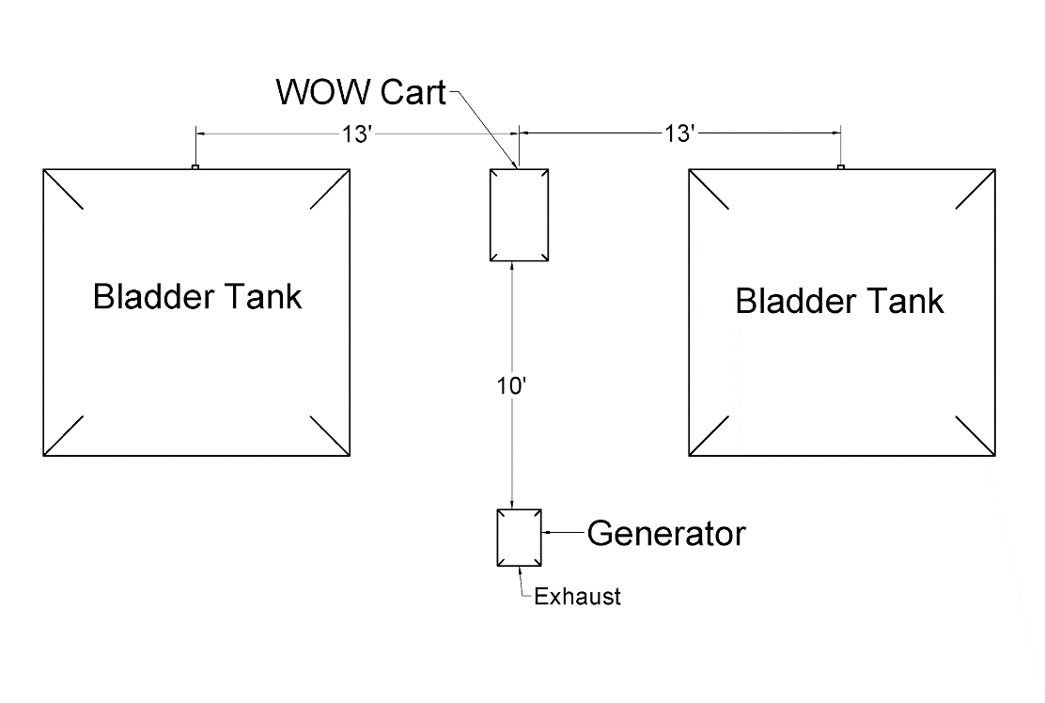
Field Set-up and Installation
Figure 1. WOW Cart Field Installation Set-up
- When using the WOW cart, remove the tarps from the bladder tanks and lay them flat on the ground on either side of the WOW cart, as pictured above.
- Remove the two 1250-gallon bladder tanks and lay them flat on the ground on top of the tarps. Make sure that the bladder side opening is facing the front of the WOW cart where the pump is, and the openings of each bladder are about 13 feet from the center of the WOW cart. Take care not to set the bladder tank on sharp objects that may puncture them.
- Insert the single hole manifold inlet pipe into the front openings of the bladder tanks.
- Place the generator 15 feet from the WOW cart. The treatment device cords are roughly the length needed if laid between the WOW cart and the generator without slack.
- Make necessary electrical connections between generator/grid and unit processes desired (Figure 2)
- It is recommended to place the generator between the two bladder tanks with the exhaust facing away from the WOW cart and the bladder tank
Figure 2. Electrical Configurations

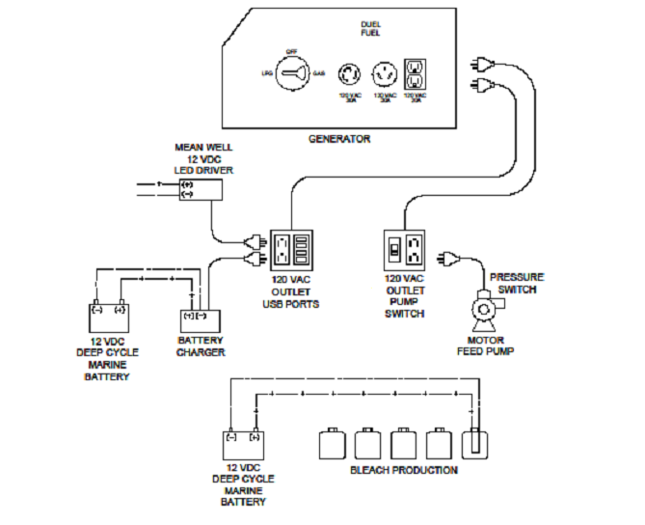

Water Treatment

Connecting the Water Source

Pressurized water source from a hose:
- Attach a drinking water safe hose from the access point to the 3/4" Female Camlock to MHT Adapter near the pump at the bottom of the WOW cart.
- When ready to start treating water, turn the valve directly above the adapter near the jet pump to the open position.
- Make sure the other two valves around the jet pump are turned off.
- The WOW cart components are rated to withstand normal drinking water distribution system pressures.

Unpressurized water source:
- Connect hose # 6 to quick connect (Z) and (Y) (foot valve)
- Ensure that the bottom of the WOW cart is no more than 17 feet higher than the water source. The jet pump can pull water up to 17 feet vertically.
- Attach the included suction hose to the jet pump via the check valve.
- Attach the foot valve to the open end of the suction hose.
- Drop the foot valve into the water source.
- Turn the valve closest to the pressure gauge on the jet pump to the open position.
- Make sure the other two valves near the pump are turned to the closed position.
Figure 3. Water Supply Connections

Determining the Water Treatment Flow Path

The water treatment processes selected will depend on whether bacteria, chemicals, dirt, or radiological contamination needs to be removed from the water and the desired level of treatment for the intended use or disposition of the treated water. The manifold (water flow) can be configured in different ways to optimize the needed water treatment. The schematic (Figure 4) and Table 1 below describe the full path that will treat the broadest group of contaminants. A 100% removal should not to be assumed for any contaminant. Optional flow paths for specific contaminants are found in Appendix A.

For individual flow path options, please refer to Appendix C – Supplemental User’s Guide for Standard Use and Configuration.

Figure 4. Complete Treated Water Flow Path

Table 2. Fully Operational Flow Path

Contaminants to be removed:

Bacteria/Virus, Chemicals/Radiological, Turbidity(cloudy)
Technologies To Be Used:
1) 100- and 25-micron Disc Filters (cloudy, dirty water)
2) Star Canister Carbon Filters (chemicals)/Ion Exchange (radiological)
3) UV System (step 1 disinfection of bacteria and virus)
4) WaterStep M100 ChlorineGenerator (final disinfection)

Actual Process Flow:
Source water, feed pump, screen/disc filters, canister carbon filters, UV system, chlorine generator, bladder tank.

Setup Procedure:

- Connect hose #1 to quick connect (K) and (P)
- Connect hose #2 to quick connect (F) and (Q)
- Connect hose #3 to quick connect (B) and (R)
- Connect hose #4 to quick connect (S) and (T)
- Connect hose #5 to quick connect (U) and (I)
- Close valves: V0, V2, V3, V4, V5, V7, V8, V9, V10, V11, V13, V15, V16, V17, V18, V19, V21
7) Open valves: V1, V6, V12, V14, V20, V22

- Turn the correct valves to the open position so the water follows in the desired flow path direction. See the manifold schematic (Figure 2) determine what valves need to be opened and where bypass hoses need to be connected for this setup.
- Before running water through the WOW cart, follow the flow path to ensure only the desired valves are open so that backflow through the system does not occur.

Filling Bladder Tanks with Treated Water
- From the output point on the manifold, use the 1" Female Camlock to MHT Adapter to attach a drinking water safe hose and run it into the top opening of the bladder tank.
- Begin filling the bladder tank.
- While the tank is filling, continuously monitor the chlorine residual level through the full port ball valve on the manifold and keep it around the desired level. To control the flow of chlorine gas into the water, the M-100 can be generally controlled with a valve on the small chlorine hose on the M-100’s venturi as needed. Power to the M-100 Chlorine Generator can be disconnected if chlorine generation is not desired.
- Once the desired quantity of water is in the tank, turn the pump off using the switch in Outlet Box A (if using an unpressurized source) or turn off the pressurized source at the access point.
- Let the water sit and have a contact time of one hour. The suction hose and drinking water safe hose can be disconnected from the pump and stowed for easy access at this time.

Recirculation of Treated Water
There are two scenarios when recirculation through the WOW cart could be required. These are to 1) further treat exceptionally dirty water and to 2) polish (reduce excess chlorine residual) water to improve the taste and odor for drinking. If particularly difficult to disinfect contaminants are present or if concentrations are excessively high, additional passes of the treated water from the bladder tank through the disinfection processed to the WOW Cart can be made to treat the water to the desired level. If water is going to be used for cooking or drinking, it is recommended that the water be polished via filtration (typically GAC) to remove unwanted tastes and odors from the chlorine residual.

To recirculate water for the purpose of polishing it, refer to Figure 5 and follow the steps listed below.

Polishing Set-up Procedure
- Turn off the jet pump via the switch in outlet box A
- Remove the foot valve from the suction hose and connect it to the ¾” female to 1” male camlock adapter.
- Connect the adapter end of the hose to quick connect (Z) (single hole manifold).
- Connect the loose end of the suction hose to the jet pump at the check valve.
- Connect hose #1 to quick connect (J) and the inlet side of the canister
- Connect hose #6 to the outlet side of the canister and quick connect (K)
- Connect the ¾” female to MHT adapter to quick connect (W)
- Connect the drinking water safe hose to the adapter.
- Connect the other end of the hose to the desired distribution point or points.
- Close Valves: V7, V8, V9, V19, V20, V21
- Open Valves: V6, V10, V16, V14, V22
- Turn the jet pump back on.
Figure 5. Recirculated and Treated Water for Distribution

Filter canisters can remain on the WOW cart (other treatment in Figure 5) or placed next to the WOW cart for ease of access during polishing. Once modifications have been made, turn the jet pump back on at the switch, it will supply pressurized water to the distribution points. If distribution is not needed, the hose can be inserted back into the top of the bladder tank for storage until use.

Additional Disinfection Set-up
To recirculate water for the purpose of treating it further, follow the steps below to route the flow through the M-100 (red line/blue line path).

- Turn off the jet pump via the switch in outlet box A
- Remove the foot valve from the suction hose and connect it to the ¾” female to 1” male camlock adapter.
- Connect the adapter end of the hose to quick connect (Z) (single hole manifold).
- Connect the loose end of the suction hose to the jet pump at the check valve.
- Do not change any hoses or valves from the original treatment path.
- Ensure that quick connect (W) is still connected to the 1” female to MHT adapter and the drinking water hose is still running into the top of the bladder tank.
- Turn the jet pump back on.
Once recirculation has started, water can be recirculated and tested at one of the valves on the single hole manifold until it meets the desired water quality level.

Treated Water Distribution
There are two distinct scenarios that can occur during distribution. They are listed below:

- Direct distribution to jerry cans and other personal containers from bladder tanks.
- Pressurized distribution to support systems (showers, kitchens, restrooms, etc.)

Direct Distribution to Individuals
For direct distribution from the bladder tanks, connect the 1” female to MHT adapter to the male quick connect (Z) on the single hole manifold. Then connect the drinking water safe hose to the adapter. At this point, the hose can be used for distribution.

Pressurized Distribution Set-up Procedure
As discussed previously, polished water can be delivered directly to the distribution point under pressure, but water can be delivered from the bladder tanks to desired distribution points under pressure via the following setup.

- Turn off the jet pump via the switch in outlet box A.
- Remove the foot valve from the suction hose and connect it to the ¾” female to 1” male camlock adapter.
- Connect the adapter end of the hose to quick connect (Z) (single hole manifold).
- Connect the loose end of the suction hose to the jet pump at the check valve.
- Connect hose #1 to quick connect (J) and (K).
- Connect the ¾” female to MHT adapter to quick connect (W)
- Connect the drinking water safe hose to the adapter.
- Connect the other end of the hose to the desired distribution point or points.
- Close Valves: V7, V8, V9, V19, V20, V21
- Open Valves: V6, V10, V16, V14, V22
- Turn the jet pump back on.
When water is being distributed under pressure, the jet pump will automatically control the pressure via the pressure switch. In this circumstance, multiple distribution points can be connected (via hose splitters).

Cleaning, Storing, and Transportation

Cleaning

It is recommended that a bleach solution be run through the system prior to storage by siphoning the solution in via a 5-gallon bucket, ensuring each line of the system gets disinfected. The bladder tank can be sanitized (inside and out) using a mild bleach solution and hung up vertically with the outlet pointing towards the ground and open, then blow back into the tank until dry. The best way to do this is with a wet and dry shop vac on blow mode or a leaf blower connected to the top opening of the tank.

Storing

Before storing, completely drain the system of all water. This includes hoses, filters, filter housing, pumps, and valves. DO NOT fold up and store bladder tanks wet. There is a drain valve on the bottom of the jet pump that needs to be opened and water drained out of the pump volute. Open camlocks (without drained hoses attached) should be capped with ¾” Female Camlock Caps to prevent insects and contaminants from entering the system when in storage. The WOW cart should be stored in a safe and secure area.

Generator

The generator needs to be depleted of fuel and the negative on the battery on the generator needs to be disconnected. If fuel cannot be removed, a fuel stabilizer needs to be introduced into the gas tank for storage. If only using propane, this is not an issue.

The battery should be on trickle charge while in storage, so it is fully charged when deployed. All parts and pieces should be stowed together so it remains a unit during transport.

Transportation

When the WOW cart is being prepared for transport, the M-100 should be removed from the WOW cart upper manifold and packaged separately to reduce the risk of damage to the unit. When transporting, secure the load so it does not move freely.

Maintenance

For best results in maintaining your new equipment it is advised that:

- The WOW Cart is always sitting on its wheels in the upright position with the two locking castors locked in place in use and in storage.

- When the WOW Cart is in use, keep the equipment wiped off and free of dirt and debris at all times. This will allow the operator(s) to see if there are any leaks or other issues that may need to be addressed. Salt and its by-products such as chlorine, chlorine gas, sodium hypochlorite (Bleach) and sodium hydroxide are corrosive to metals, warning stickers, and placards.

- Daily check the oil level in the Dual Fuel Generator. See Generator manual.

- The Dual Fuel Generator should be drained of fuel or the remaining gasoline stabilized with a stabilizer prior to storage. Stabilizer can be found at an auto parts retail store and is not included with the WOW Cart. See the dual fuel generator manual for instruction.

- The WOW Cart should be sanitized and drained of all water from all of the filters, manifolds, plumbing, piping, pumps, M-100 Chlorine Generator and BleachMakers prior to storage. See manual for sanitizing process.

- The activated carbon filter canisters need to be removed from the WOW Cart after use and the granular activated carbon and sand removed and replaced. See the media manual for instruction.

- The 12- volt Deep Cell Battery should remain connected to the battery charger with the battery charger plugged into a reliable power source at all times when the WOW Cart is in use or in storage. This will assure the user(s) that the battery is fully charged at all times. See the battery charger manual for instruction.

- Inspect all electrical utility cords prior to use. If you find any electrical utility cords or extension cords that have been compromised with cuts, nicks or have been crushed, replace the cord and discard the compromised cord. Keep all electrical utility cords and extension cords dry, clean and free of dirt and grime.

- Always keep the equipment manuals with the W.O.W. Cart for reference.

Troubleshooting

Always refer to the supplied WOW Cart and component manuals for function and processes as well as any manuals that are supplied with the additional accessories for function and process. Typical operational issues that may arise during operation:

- Water running at a normal rate through the cart and then all suddenly slowly through the system is usually an indication that one or more water filters are plugged up. One or all will need to be cleaned (rinsed) or have the media replaced.

- Generator quits running. Check the gasoline or propane tank.

- WOW Cart not operating but the generator is running. Check to be sure cords are plugged in.

- Leak on a cam-lock quick connect hose. Check that both lock levers are fully engaged in the lock position. Though highly unlikely, the female cam-lock fittings have a gasket inside them. Be sure that the gasket is in place.

- The jet pump stops pumping water from the source. Check the foot valve on the end of the 1” suction hose. It may be plugged with dirt and debris and require cleaning.

Contact Information
Contact WaterStep at:
info@waterstep.org
Phone: Monday through Friday from 9:00 am to 5:00 pm Eastern Standard Time (EST), U.S.A. at: +1-502-568-6342

For further Information or specialized training on the WaterStep WOW Cart, or any of the other WaterStep products and services, please contact;

WaterStep
625 Myrtle Street
Louisville, Kentucky 40208 U.S.A
+1 502 568-6342
info@waterstep.org

Glossary

A

Access point
If using a pressurized source, the point at which water can be retrieved and tied into the flow path of the WOW cart. Example: a challenged municipal water supply at a hose bibb, tap, or valve.

Appliance cord
Any cord that is attached to an energy-requiring component of the WOW cart.

B

Bypass point
The male camlock connections below the main manifold.

C

Camlock
A watertight quick disconnect mechanism which can be used to easily reroute the path of flow.

Check valve
A one-way valve that retains pressure within the system and is crucial to the proper function of the jet pump.

Chlorine hose
The small white tube that runs from the chlorine side of the M100 to the venturi.

Contact time
After chlorination, the time required for the water to set before chlorine can be removed and/or water can be consumed.

D

Distribution point
The point at which water is being retrieved for use either in cooking, cleaning, drinking, bathing, etc after treatment.

F

Filter media
The chemical or mechanical component which water is passed through during treatment.

FHT
Female Hose Thread.

Flow path
The path water will take from the original source to the final distribution point.

Foot valve
A one-way back flow prevention valve with a coarse screen which can be placed in an open water source.

G

GFCI
Ground Fault Circuit Interrupter. A specialized outlet which is grounded and will shut off if an electrical hazard is detected.

M

MHT
Male Hose Thread (Also known as National Hose – NH)

Manifold
A portion of pipe which is used in controlling the flow of water in a defined path.

P

Polishing water
Treating water post-chlorination to remove residual chlorine, odor, and taste.

Primary treatment
Treatment that occurs prior to chlorine contact time.

S

Suction hose
A hose that contains rings of PVC to resist collapsing under vacuum.

T

Tank, bladder, or pressure
A large, portable water storage tank that can be folded down and stored when not in use.

Tank, pressure
A tank that contains an air bladder and is connected to a pressure switch that allows for automated control of a jet pump.

Treated water
Water which has passed through at least one aspect of treatment on the WOW cart.

V

Venturi
A small section of pipe that rapidly constricts in size before returning to the original size, creating a vacuum.

Volute (Found in Jet Pump)
A curved funnel that increases in area towards the discharge point.

W

Water source, pressurized
A source which will flow through the WOW Cart without the need for the included pump. Example: municipal supply, elevated tank.

Water source, unpressurized
A source that requires a pump to flow through the WOW Cart. Example: lake, pond, stream, ground level tank, shallow well.

Appendix A. Alternative Water Treatment Flow Paths

Moderately Contaminated Water

Contaminants to be treated:
Bacteria/Virus, Chemicals, Turbidity (cloudy)
Technologies To Be Used:

1) 100- and 55-micron Screen/Disc Filters
2) Canister Carbon Filter
3) WaterStep M100 Chlorine Generator

Actual Process Flow:
Source water, feed pump, screen/disc filters, canister carbon filters, chlorine generator, bladder tank.
Setup Procedure:

1) Connect hose #1 to quick connect (K) and (P)
2) Connect hose #2 to quick connect (Q) and (T)
3) Connect hose #5 to quick connect (U) and (I)
4) Close valves: V0, V2, V3, V4, V5, V7, V8, V9, V10, V11, V12, V13, V15, V16, V17, V18, V19, V21
5) Open valves: V1, V6, V14, V20, V22

Quick Disinfection

Contaminants to be treated:
Bacteria and Virus
Technologies To Be Used:
1) 100- and 55-micron Screen/DiscFilters
2) WaterStep M100 Chlorine Generator

Actual Process Flow:

Source water, feed pump, disc filters, chlorine generator, bladder tank.

Setup Procedure:

1) Connect hose #2 to quick connect (K) and (T)
2) Connect hose #5 to quick connect (U) and (I)
3) Close valves: V0, V2, V3, V4, V5, V7, V8, V9, V10, V11, V12, V13, V15, V16, V17, V18, V19, V21
4) Open valves: V1, V6, V14, V20, V22

Appendix B. Manuals

      - M-100 Chlorine Generator Manual

2. BleachMaker Manual

3. BleachMaker 110V AC Power Supply Connection

Appendix C. Filter Media Types and Uses
(Others may be considered depending on water quality and issues present)

INCLUDED WITH WOW CART:

Granular Activated Carbon (GAC)  (INCLUDES 2 REFILLS) | Granular carbon is the standard media for most chemical reduction situations. Its high surface area gives it massive adsorptive capacity. It can be manufactured from animal bones, wood, and petroleum, but most carbon is produced from anthracite coal or coconut shells.

NOT INCLUDED:

Media | Description
Activated Alumina | Activated Alumina is “a mixture of amorphous and gamma aluminum oxide” that is used for removal of arsenic, fluoride, selenium, silica and humic acids.
Anthracite | Crushed anthracite coal has long been a favorite medium-weight filter for sediment reduction. It is now most often used with sand and other media in multi-media filters.
Copper-zinc mixtures | High purity copper/zinc granules that use redox (exchange of electrons) to remove chlorine and heavy metals. 50% copper and 50% zinc mixtures are typically used for chlorine and heavy metals reduction. It also has bacteriostatic properties. 85% copper and 15% mixtures are typically used for iron, manganese and hydrogen sulfide reduction.
Crushed marble | Crushed marble is naturally occurring calcium carbonate. It is used to raise the pH of acidic water.
Garnet | Garnet is a natural medium used most often in multi-media filters. It is very fine and filters down to the 10-20-micron range.
Ion Exchange Resin | Various acid cation and base anion mixtures that that are used for primary for softening and water treatment rad waste treatment and decontamination.
Manganese Greensand | Manganese greensand is a purple-black filtration medium made from naturally occurring greensand coated with manganese. Manganese dioxide is similar. It serves as a catalyst to precipitate hydrogen sulfide, iron and manganese.
Multi-media (multi-layer) | Multi-media filters consist of several layers—usually three to five—of different media. The media are loaded by density—the densest in the bottom of the tank, the least dense on top. This produces a filter with excellent flow rate and relatively easy backwash properties that will filter down to ten microns.  The most common media mix is (top to bottom): anthracite, filter sand, garnet. This is a typical mix, though many others are common.
Sand | Filter sand is naturally occurring sand that is high in silica and low in calcium. It is graded and washed. It can be used independently or as part of a multi-media filter. Sand filters are believed to be the oldest man-made filters and they imitate a common natural filtration technique.
Zeolite | A natural material composed of a microporous arrangement of silica and alumina used for the filtration of heavy metals, ammonium, and some organics.

Adapted from http://www.purewaterproducts.com/articles/filter-media

